 Assignment Cover Sheet
Student Information (For group assignment, please state names of all members) |  | Grade/Marks
Name | ID
KABIR RAJBHANDARI | E2300558
SAILESH MAHARJAN | E2300572
SAKSHAM SHARMA SEDHAI | E2300573

Module/Subject Information |  | Office Acknowledgement
Module/Subject Code | BIT216
Module/Subject Name | Software Engineering Principles
Lecturer/Tutor/Facilitator | Sudeep Lal Bajimaya
Due Date | 12 June 2026
Assignment Title/Topic | Assignment 1 – Task 1
Intake (where applicable) | Nov 2023
Word Count | 2508 | Date/Time
Declaration
- I/We have read and understood the Programme Handbook that explains on plagiarism, and I/we testify that, unless otherwise acknowledged, the work submitted herein is entirely my/our own.
- I/We declare that no part of this assignment has been written for me/us by any other person(s) except where such collaboration has been authorized by the lecturer concerned.
- I/We authorize the University to test any work submitted by me/us, using text comparison software, for instances of plagiarism. I/We understand this will involve the University or its contractors copying my/our work and storing it on a database to be used in future to test work submitted by others.
Note: 1) The attachment of this statement on any electronically submitted assignments will be deemed to have the same authority as a signed statement.
2) The Group Leader signs the declaration on behalf of all members.
Signature: | Date: 12/06/2026
E-mail: kabir.rajbhandari23@midvalley.edu.np

Feedback/Comments*
Main Strengths
Main Weaknesses
Suggestions for improvement

 | Student acknowledge feedback/comments
Grader’s signature | Student’s signature: kabir.rajbhandari23@midvalley.edu.np
Date: | Date: 12/06/2026
Note:
- A soft and hard copy of the assignment shall be submitted.
- The signed copy of the assignment cover sheet shall be retained by the marker.
- If the Turnitin report is required, students have to submit it with the assignment. However, departments may allow students up to THREE (3) working days after submission of the assignment to submit the Turnitin report. The assignment shall only be marked upon the submission of the Turnitin report.
*Use additional sheets if required.

Business Proposal / Plan
ZeroWaste: A Smart Food Waste Management and Household Food Management

Table of Contents
Abstract i
Acknowledgement ii
1. Overview 1
1.1. Motivation 1
1.2. Customers and Users 1
1.3. Project Deliverables 2
1.4. Cost Estimation 2
1.5. Timeline 2
2. Project Aims 3
3. Project Objectives 4
4. Project Scope 5
4.1 In Scope 5
4.2 Out of Scope 5
4.3 Use Case Summary 6
5. Project Schedule 8
5.1 Work Breakdown Structure (WBS) 8
5.2 Milestone and Deliverables 10
5.3 Gantt Chart 11
6. Technical Description 12
6.1 Development Platforms 12
6.2 Demonstration Platform 16
7. Risk Management Plan 17
Works Cited 20
8. Marking Scheme 21

Table of Figures

Figure 1: Use Case Diagram: 6
Figure 2: WBS sub-category 1 and 2 8
Figure 3: WBS sub-category 3 9
Figure 4:WBS sub-category 4 9
Figure 5: WBS sub-category 5 10
Figure 6: Overall WBS Hierarchy 10
Figure 7: Gantt Chart - Project Schedule Timeline 12

Lists of Table

Table 1: Use case 1 summary 7
Table 2: Use case 2 summary 7
Table 3: Use case 3 summary 7
Table 4: Use case 4 summary 7
Table 5: Use case 5 summary 7
Table 6: Use case 6 summary 7
Table 7: Table of Development Platform Listing 12

Abstract
This business proposal/plan presents ZeroWaste, a web-based food waste management and household food inventory system designed to address the growing issue of food wastage among households. The proposed system aims to assist users in managing food inventories efficiently through features such as expiry-date tracking, real-time notifications, food donation facilitation, food analytics, and weekly meal planning. By encouraging responsible food consumption and reducing unnecessary waste, the platform contributes to both environmental sustainability and community welfare.
A comprehensive project proposal/plan has been developed, including project scope, objectives, technical specifications, risk management strategies, Work Breakdown Structure (WBS), milestones, and development timelines. The system will be implemented using modern web technologies including React.js for front-end development, Spring Boot for back-end services, and PostgreSQL for database management.
Overall, ZeroWaste aims to promote sustainable household food management practices by leveraging technology to reduce food waste, improve food utilization, and create a community-driven platform for sharing surplus food resources.
Acknowledgement
We would like to express our sincere thanks to our lecturer for guiding us throughout this project proposal/plan and providing invaluable feedback that shaped the direction of our work.
Our appreciation also goes to our teammates, Kabir Rajbhandari - E2300558, Sailesh Maharjan - E2300572 and Saksham Sharma Sedhai - E2300573 for their collaborative efforts, creativity, and commitment at every stage of the project plan and proposal.
- Overview
Malaysia generates more than 39,000 tonnes of solid waste every single day. That is roughly 1.17 kg per person which is above the global average, and the number keeps climbing. (Chang Wei Jie, April 23, 2026). This increasing crisis damages our food ecosystem, the environment, and the economy including the unwanted consumption of water, land and resource used for food production.
To reduce the major problem of food waste, household food waste, ZeroWaste is a smart web application (an intelligent inventory management system), we have designed to help users/customers manage their food inventory, track the expiration dates, receive timely alerts and notifications, search for food items, food analytics, facilities for donation and with added functionality for meal planning. While doing we have given our attention towards protecting user data and account privacy.
  - Motivation
The main motivation for this project comes from the increasing concern of food waste and its impact on environmental and economic factors. As in Malaysia and everywhere, food is central to our daily needs and our culture, and still the gap between food consumption and food management is huge. Here is a number to get a better picture, Malaysia produced 15.2 million tonnes in 2024 and is projected to reach 17.03 million tonnes by 2035. (Chang Wei Jie, April 23, 2026)
With this increasing issue, ZeroWaste is motivated to help minimize the food wastage and the proper management of the food and resources.
  - Customers and Users
The primary users for the ZeroWaste are:
- Families and household individuals, who in regular basis purchase and consume food items,
- Donors who are willing to share the food with others, before it goes to waste,
- Community members and individuals who can browse and claim the donated food items,
- Everyday individuals, who wants to track the expiry dates of the food items,
  - Project Deliverables
Our product is a new product, and not an extension of any existing project. Built to address food waste management for Malaysian households. ZeroWaste will be delivered as a fully functional, web-based application accessible via web browser.
The core features to be delivered include:
- User registration and account privacy,
- Two-Factor authentication and privacy management,
- Food inventory management with tracking expiry dates,
- Food donation - donating and cleaning food items,
- Real time notification system for expiry and donations,
- Food analytics,
- Weekly meal planning based on the current food inventory
  - Cost Estimation
The project will be developed by our team of three members, contributing our own computing hardware, development will be done all using open-source tools and free available platforms, keeping the development cost minimal.
  - Timeline
The development timeline for the ZeroWaste is estimated at approximately 13 to 14 weeks, divided into two phases, which is aligned with the assignment submission deadlines, Phase 1 and Phase 2 for coding and testing.

- Project Aims
The main aims for the development of ZeroWaste are listed below:
- To develop a user friendly, web application that helps Malaysian households to effectively reduce food waste,
- To help user adapt to sustainable consumption practice by providing appropriate tools to manage food inventory responsibly and efficiently,
- To facilitate a community-driven food donation environment where surplus household can donate to the ones in need,
- To facilitate the optimal utilization of every food item available through expiry date tracking and weekly meal planning,
- To help user remember the inventory and supplies by timely notifications, and result in less food waste.

- Project Objectives
Upon the completion of ZeroWaste project, we aim to build a system which can reduce the food waste being produced and change the number of degrading conditions of food management to some sort better than what we began from. The following are the specific objectives we aim to achieve:
- To design and implement a secure user registration and privacy setting with two-factor authentication (2FA),
- To build a functional food inventory management system, allowing use to add, update (edit), categorize, and delete food items, that also tracks the food item used,
- To build a functional expiry date tracking system which notifies the user,
- To implement a food donation feature, to list users the surplus item in their inventory, browse through available donation made, and claim items. A fully functional donation flow,
- To build real-time notification features that alerts users days prior to the food expiry date of the stored items, notify when a donation is made,
- To provide user the visual food analytics for the stored food items, tacking each user’s food saving and waste statistics,
- To provide user the ease to search the food items stored in their home from anywhere with access to internet,
- To develop a weekly meal planner feature that suggest meal plan according to their current inventory, reducing ingredient redundancy and food wastage,
- To ensure the system aligns with usability and performance standard, including a target load time under 2 seconds, meeting security standards, and
- To develop a hierarchical design to help user navigate through the system

- Project Scope
The scope clearly defines the boundaries of ZeroWaste, clearly stating what the system will and will not deliver. This is essential to manage the expectation of the project, avoid scope creep, and ensure that the project aligns with project objectives.

4.1 In Scope
The following functionalities will be developed as part of ZeroWaste (will deliver part of our project):
- User Registration and Privacy Settings: New users can register with their email and password. Two-factor authentication is implemented. Users can maintain a basic level of account preferences from their account,
- Food Inventory Management: Users can add, view, edit and delete food items, from their inventory. Each item includes details such as name, quantity, expiry date, category,
- Make donation: Users can donate the food items in their inventory, i.e. convert the items from inventory listing to donation listings,
- Browse and claim food donations: Users can search for food items listed by other users for donation, filtering by categories and expiry date. Items details include the pickup location and contact methods. Users can request and claim donation,
- Food Analytics: Users can see visual report generated by the system, showing users with their food saved, food donated and waste reduced doing so.
- Notification systems: Provide a real time notification for: 3-4 days prior to the food expiry date, when the donation request is verified, meal planning reminder, and security alert.
- Weekly Meal Planning: Users get weekly meal plans using their existing inventory. The system only gives the ingredient-based meal suggestions.
- Reminders: Meals planned are linked with the items and meal reminders

4.2 Out of Scope
The out of scope are the features and usability that will not be included to this project to maintain a realistic and focused development:
- Online payment: Users don’t need to buy and sell any good from our site; thus, no financial transaction is required in the application.
- Third-party Delivery system: Our system ZeroWaste doesn’t need any delivery system for food transportation; for transporting donating goods.
- Mobile Native Application: ZeroWaste will be delivered only as a web-based platform. IOS and Android application are not in our scope to produce, for now.
- Multi-language support: ZeroWaste will be built, tested and launched in English only.

4.3 Use Case Summary
The given figures give us the overview of what the system need to perform:
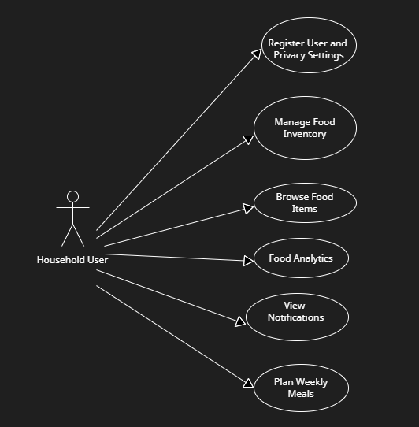
Figure 1: Use Case Diagram

Use Case 1: Register User and Privacy Setting
- Any user can register on the platform,
- And maintain their privacy setting such like 2FA and food listing visibility, which can be updated any time from the account dashboard
Table 1: Use case 1 summary
Use Case 2: Manage Food Inventory
- Any user log into their system and log the inventory of food they have with the information like name, category, expiry date. There they can also change the food item to the donation listing easily.
Table 2: Use case 2 summary
Use Case 3: Browse Food Items
- Any user browses through the donation listing made based on location and type, and the listing has the pickup details and items details. Here they can request and claim for the donated goods.
Table 3: Use case 3 summary
Use Case 4: Food Analytics
- An analytics report on food saved, consumed and donations made
Table 4: Use case 4 summary
Use Case 5: View Notifications
- Notification will be sent to the users for the food expiring in 3-4 days, confirmation for the donation request.
Table 5: Use case 5 summary
Use Case 6: Plan Weekly Meals
- Any user can plan their weekly meal based on available food item or suggest based on expiry date with available items.
Table 6: Use case 6 summary

- Project Schedule
For the development of ZeroWaste we have been given to apply Iterative and Incremental Development Methodology, thus the project is divided into two development iteration (Iteration 1 and Iteration 2), each contributing for the increment of the system. The main advantage on applying this methodology is that it allows for early validation of features and progressive enhancement in later iterations.

5.1 Work Breakdown Structure (WBS)
For a view of deliverable-oriented hierarchical decomposition of the work to be done and completed, the following WBS has been created.
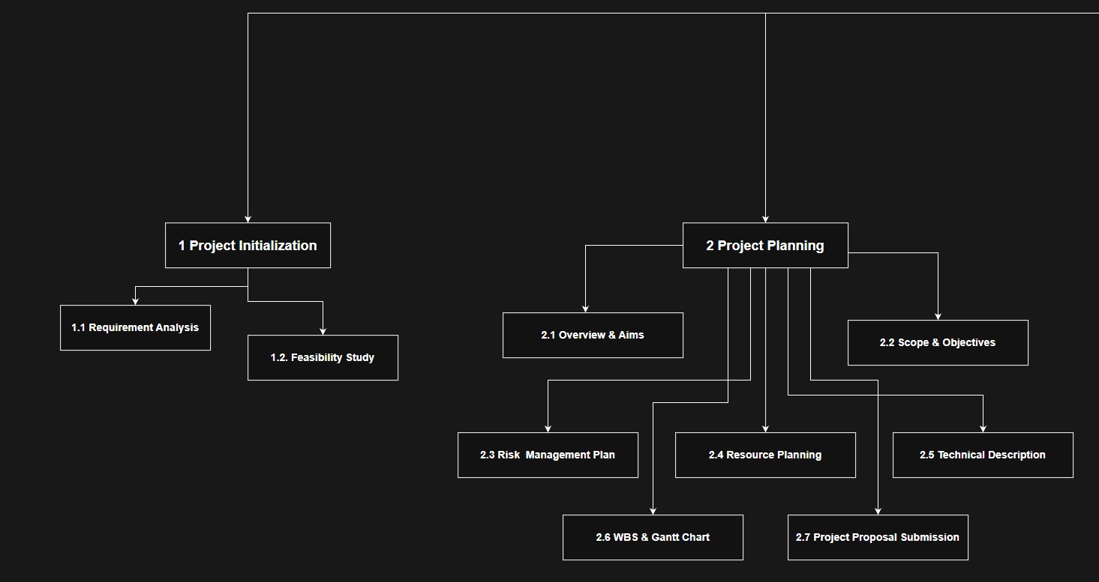
Figure 2: WBS sub-category 1 and 2
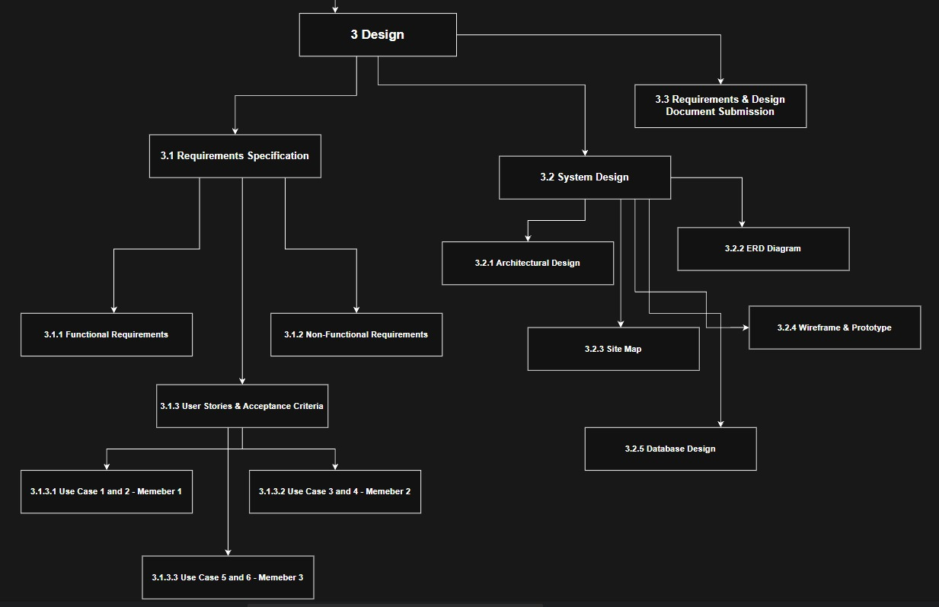
Figure 3: WBS sub-category 3
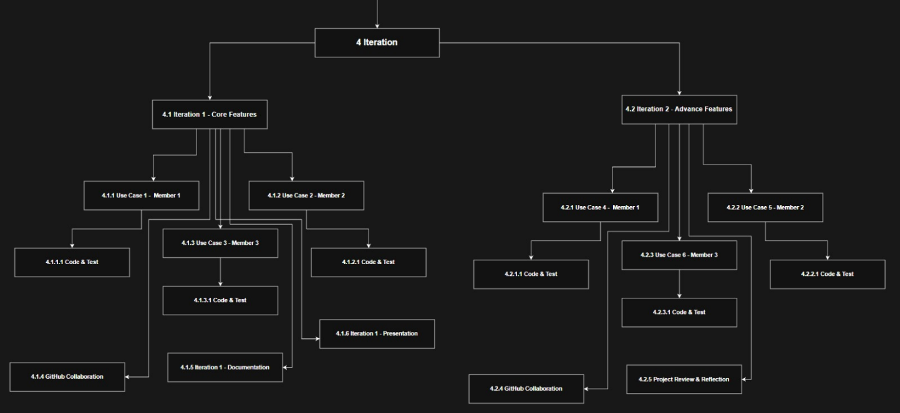
Figure 4:WBS sub-category 4
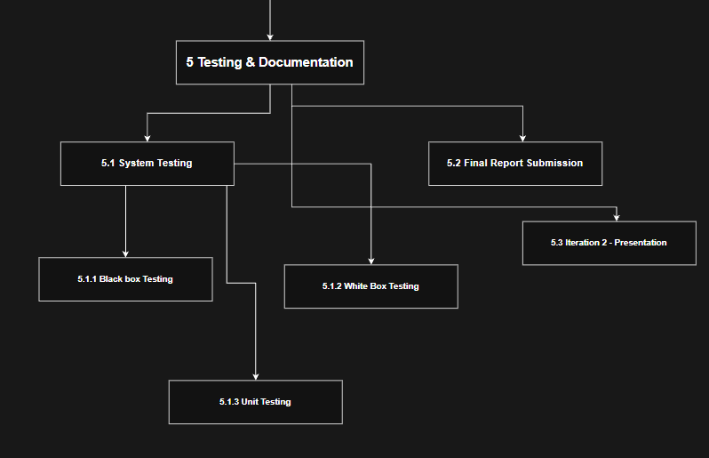
Figure 5: WBS sub-category 5
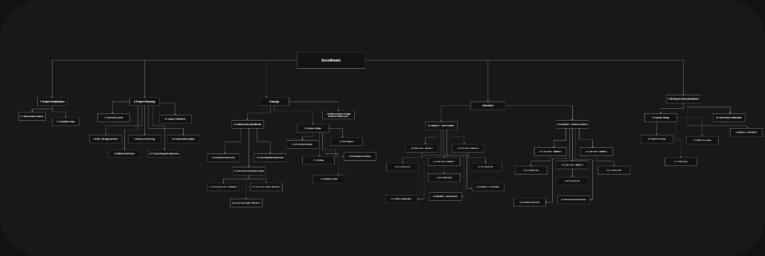
Figure 6: Overall WBS Hierarchy
Note: The chart was created using draw.io, and the .io project file is maintained in the team’s GitHub repository.

5.2 Milestone and Deliverables
The milestone and deliverables, provides the fixed date for the task to be complete, this helps to determine the work, and deliverables are being completed on time.
S.no | Milestones | Target Date | Criteria for Completion
M1 | Project Proposal Submission (Task 1) | 12th June, 2026 | Task 1 document submitted on HLMS with all required sections completed.
M2 | Requirement Specification and Design Submission (Task 2) | 25th June, 2026 | Both functional and Non function requirements are met alongside user stories & Acceptance Criteria and System Designs.
M3 | Iteration 1 Submission and Presentation | 15th July, 2026 | UC1, UC2, UC3 are completed and tested alongside GitHub collaboration.
M4 | Iteration 2 Submission and Presentation | 21st August, 2026 | UC4, UC5, UC6 are completed and tested alongside GitHub collaboration.

5.3 Gantt Chart
The Gantt chart below provide a visual timeline of the ZeroWaste project for 13 - 14 weeks. It contains resource allocation across team members, and key milestones.
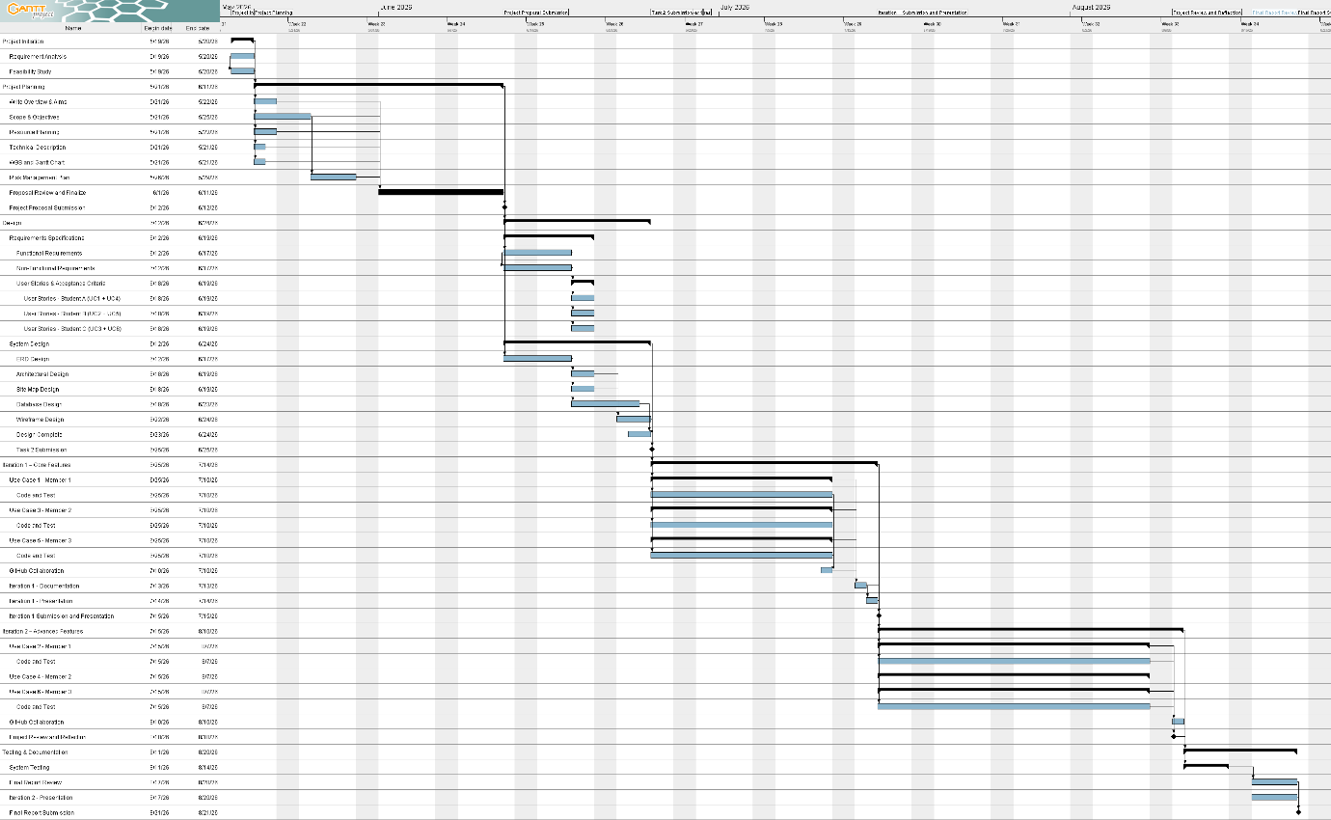
Figure 7: Gantt Chart - Project Schedule Timeline
Note: The chart was created using GanttProject, and the. gan project file is maintained in the team’s GitHub repository.
- Technical Description
The technical description as its name is, outlines the languages, tools and frameworks, and hardware that are to be used in every phase of the development of the ZeroWaste web application:

6.1 Development Platforms
Table 7: Table of Development Platform Listing
Criteria | Tools and Hardware | Version | Description
Documentation
Documentation | MS Word | Office 2024 | Writing of project document, like project plan and proposal, and Requirement Specification.
Modeling and Diagram | Draw.io | Latest | To draw WBS, ER, Database Diagram,
Modeling and Diagram | GanttProject | 3.3 | To make gantt chart with resource allocation and timeline formation.
Modeling and Requirements
Requirements Tracking | MS Word | Office 2024 | A document will be made to look and sort issue, track user stories and epics.
Design and Prototyping | Figma | Latest | To make wireframe design, high-fidelity and interactive prototyping
Project Management and Collaboration
Version Control | GitHub | Latest | Collaborate among multiple team members by keeping an online source code versioning.
Communication | WhatsApp and Discord | Latest | For Team communication, document and resource sharing. Conducting team meeting and discussion.
Framework - Frontend
Frontend Language | HTML5 | Living Standard | Basic building block of any website, Will be used to define every element and class on the website.
Frontend Framework | React.js | 19.2.7 | Component-based UI development for the web development.
Styling | Bootstrap | Latest | CSS design for responsive design and hierarchical design.
Framework - Backend
Backend Framework | Spring Boot | Latest | RESTful API development, for business logic and server-side operations.
Authentication & 2FA | Spring Security | Latest | Session management, role-based access control, and 2FA support.
Database
Database | PostgreSQL | 18 | Free and opensource database, this stores the data in a Relational Database Management System.  All the images, and data and logins details are stored here in the relational database
Hardware (Development and Testing)
Device 1 specs  (Saksham Sharma Sedhai - E2300573) | - Intel core i5 - 13th Generation  - 16 GB RAM  - 8GB VRAM - RTX3080  - 512 SSD
Device 2 specs  (Kabir RajBhandari - E2300558) | - Intel core i5 -13th Generation  - 16 GB RAM  - 6 GB - RTX 4050  - 512 SSD
Device 3 specs  (Sailesh Maharjan – E2300572) | - AMD Ryzen 5 5500U  - 16 GB RAM  - 8 GB - GTX 1650  - 512 SSD

6.2 Demonstration Platform
The demonstration platform is where the project will be implements and be running during the development phase, testing phase, and the implementation phase. The following provided is our demonstration platform:
Criteria | Tools and Hardware | Versions | Descriptions
Browser | Google Chrome | Latest | Primary Browser for observing the development, and accessing the ZeroWaste web application
Browser (Alternative) | Brave Browser | Latest | Second choice of browser to test for cross platform compatibility.
Local Server | Apache Xampp | 8.0.30 | For running the backend and frontend application on local server i.e. laptop
Operating System | Windows 11 | -

- Risk Management Plan
The following table clearly identifies the risk related with our project ZeroWaste. Here explains, what kind of risk we may face, what is their likelihood to occur and how can be move past it:
Risk Name | Description | Probability | Mitigation Strategy
Delay on Development | Team Member fall behind schedule due to academic work, lack on the required technical knowledge, technical difficulties. | Medium Probability | - Tasks broken into small goals,  - Define technical requirements needed for the project, to be ready before hand
Data Loss and file Corruption | Accidental deletion and corruption of project source code or documents resulting in holdback. | Low Probability | - All file stored on GitHub with regular commits  - Document stored on Google drive,  - Redevelop only the affected files,  - Regularly updating on all team system for latest updated.
Miscommunication among team | Misaligned understanding of task requirements and project objectives among team or incompatible work between members. | Medium Probability | - Assign a team leader,  - Continuous discussion among team to maintain consistency on the project scope.  - Re-divide tasks if responsibilities overlap.
Technical Knowledge Gap | Any team member lacks the skills required to implement a specific function, resulting in delay, and task re-distribution | Medium Probability | - Task distribution based on skills and field of knowledge,  - Conduct a knowledge sharing documentation,  - Re-distribute tasks to each member,  - Reduce unwanted complexities.
Scope Creep | Team adds features more, diverging away from the project initial scopes, increasing workload and risking missed deadlines. | High Possibility | - Proper documentation of project scope objective and features in each step of planning and implementation,  - Refer to the project scope before adding new features, scope changes should be agreed by all team members.
Security Vulnerability | The application may expose user data through insecure authentications, unvalidated, inputs, or weak session management | High Possibility | - Using Spring Security for authentication,  - Implement input validation on both frontend and backend,  - Test for common vulnerabilities.

Reference link:
GitHub: https://github.com/Kabir-Rajbhandari/ZeroWaste.git

Works Cited
Chang Wei Jie. (April 23, 2026). Waste Management in Malaysia: The Complete Enterprise Guide (2026). gargeon.com.

- Marking Scheme
Student 1: Kabir Rajbhandari – E2300558
Student 2: Sailesh Maharjan – E2300572
Student 3: Saksham Sharma Sedhai – E2300573
LO | Assessment Area | Marks | Poor | Satisfactory | Good | Excellent |  | Marks
CLO2 | Appropriate level of scope coverage  [17]
CLO2 | Title | 1
CLO2 | Overview | 4
CLO2 | Project Aims | 4
CLO2 | Project Objectives | 4
CLO2 | Project Scope | 4
CLO2 | Project plan [15]
CLO2 | Work breakdown | 5
CLO2 | Milestones/Deliverables | 5
CLO2 | Gantt chart - Timelines, Predecessors, Resource Usage, milestones | 5
CLO2 | Resource planning [8]
CLO2 | Development  Hardware/Software | 4
CLO2 | Demo Environment Hardware/Software | 2
CLO2 | Risk Management [4] | 2
CLO3 | Documentation[10]
CLO3 | Format Consistency | 10
CLO3 | Spelling/Grammar | 10
CLO3 | Professionalism | 10
 | TOTAL | 50 | SubTotal  ( /50) |  |  |  |  | 0

